# Unit 1

1. **What is machine learning? Explain types of machine learning.**

Machine Learning is said as a subset of **artificial intelligence** that is mainly concerned with the development of algorithms which allow a computer to learn from the data and past experiences on their own. The term machine learning was first introduced by **Arthur Samuel** in **1959**.Machine learning enables a machine to automatically learn from data, improve performance from experiences, and predict things without being explicitly programmed

With the help of sample historical data, which is known as **training data**, machine learning algorithms build a **mathematical model** that helps in making predictions or decisions without being explicitly programmed. Machine learning brings computer science and statistics together for creating predictive models. Machine learning constructs or uses the algorithms that learn from historical data. The more we will provide the information, the higher will be the performance.

A machine has the ability to learn if it can improve its performance by gaining more data.

1. **Supervised learning**
2. **Unsupervised learning**
3. **Reinforcement learning**
4. **Semisupervised learning**

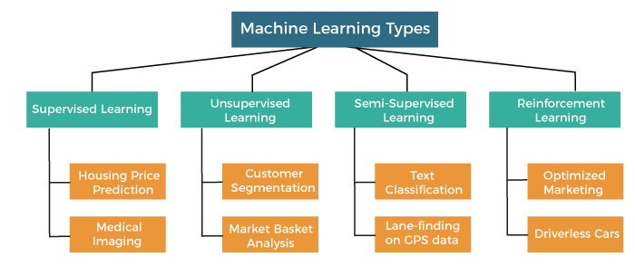

**1)Supervised Learning :**

Supervised learning is a type of machine learning method in which we provide sample labeled data to the machine learning system in order to train it, and on that basis, it predicts the output.

The system creates a model using labeled data to understand the datasets and learn about each data, once the training and processing are done then we test the model by providing a sample data to check whether it is predicting the exact output or not.

The goal of supervised learning is to map input data with the output data. The supervised learning is based on supervision, and it is the same as when a student learns things in the supervision of the teacher. The example of supervised learning is **spam filtering**.

Supervised learning can be grouped further in two categories of algorithms:

**Classification**

**Regression**

**2)Unsupervised Learning**

Unsupervised learning is a learning method in which a machine learns without any supervision.

The training is provided to the machine with the set of data that has not been labeled, classified, or categorized, and the algorithm needs to act on that data without any supervision. The goal of unsupervised learning is to restructure the input data into new features or a group of objects with similar patterns.

In unsupervised learning, we don't have a predetermined result. The machine tries to find useful insights from the huge amount of data. It can be further classifieds into two categories of algorithms:

**Clustering**

**Association**

**3)Semi-Supervised Learning :**

**Semi-Supervised learning is a type of Machine Learning algorithm that lies between Supervised and Unsupervised machine learning**. It represents the intermediate ground between Supervised (With Labelled training data) and Unsupervised learning (with no labelled training data) algorithms and uses the combination of labelled and unlabeled datasets during the training period.

**A**lthough Semi-supervised learning is the middle ground between supervised and unsupervised learning and operates on the data that consists of a few labels, it mostly consists of unlabeled data. As labels are costly, but for corporate purposes, they may have few labels. It is completely different from supervised and unsupervised learning as they are based on the presence & absence of labels.

**To overcome the drawbacks of supervised learning and unsupervised learning algorithms, the concept of Semi-supervised learning is introduced**. The main aim of [semi-supervised learning](https://www.javatpoint.com/semi-supervised-learning) is to effectively use all the available data, rather than only labelled data like in supervised learning. Initially, similar data is clustered along with an unsupervised learning algorithm, and further, it helps to label the unlabeled data into labelled data. It is because labelled data is a comparatively more expensive acquisition than unlabeled data.

We can imagine these algorithms with an example. Supervised learning is where a student is under the supervision of an instructor at home and college. Further, if that student is self-analysing the same concept without any help from the instructor, it comes under unsupervised learning. Under semi-supervised learning, the student has to revise himself after analyzing the same concept under the guidance of an instructor at college.

**4)Reinforcement Learning :**

Reinforcement learning is a feedback-based learning method, in which a learning agent gets a reward for each right action and gets a penalty for each wrong action. The agent learns automatically with these feedbacks and improves its performance. In reinforcement learning, the agent interacts with the environment and explores it. The goal of an agent is to get the most reward points, and hence, it improves its performance.

The robotic dog, which automatically learns the movement of his arms, is an example of Reinforcement learning.

1. **Explain supervised learning.**

Supervised Machine Learning

Supervised learning is the types of machine learning in which machines are trained using well "labelled" training data, and on basis of that data, machines predict the output. The labelled data means some input data is already tagged with the correct output.

In supervised learning, the training data provided to the machines work as the supervisor that teaches the machines to predict the output correctly. It applies the same concept as a student learns in the supervision of the teacher.

Supervised learning is a process of providing input data as well as correct output data to the machine learning model. The aim of a supervised learning algorithm is to **find a mapping function to map the input variable(x) with the output variable(y)**.

In the real-world, supervised learning can be used for **Risk Assessment, Image classification, Fraud Detection, spam filtering**, etc.

## How Supervised Learning Works?

In supervised learning, models are trained using labelled dataset, where the model learns about each type of data. Once the training process is completed, the model is tested on the basis of test data (a subset of the training set), and then it predicts the output.

The working of Supervised learning can be easily understood by the below example and diagram:

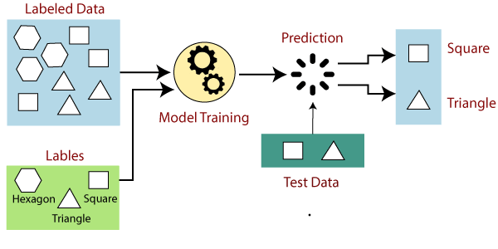

Suppose we have a dataset of different types of shapes which includes square, rectangle, triangle, and Polygon. Now the first step is that we need to train the model for each shape.

* If the given shape has four sides, and all the sides are equal, then it will be labelled as a **Square**.
* If the given shape has three sides, then it will be labelled as a **triangle**.
* If the given shape has six equal sides then it will be labelled as **hexagon**.

Now, after training, we test our model using the test set, and the task of the model is to identify the shape.

The machine is already trained on all types of shapes, and when it finds a new shape, it classifies the shape on the bases of a number of sides, and predicts the output.

## Steps Involved in Supervised Learning:

* First Determine the type of training dataset
* Collect/Gather the labelled training data.
* Split the training dataset into training **dataset, test dataset, and validation dataset**.
* Determine the input features of the training dataset, which should have enough knowledge so that the model can accurately predict the output.
* Determine the suitable algorithm for the model, such as support vector machine, decision tree, etc.
* Execute the algorithm on the training dataset. Sometimes we need validation sets as the control parameters, which are the subset of training datasets.
* Evaluate the accuracy of the model by providing the test set. If the model predicts the correct output, which means our model is accurate.

## Types of supervised Machine learning Algorithms:

Supervised learning can be further divided into two types of problems:

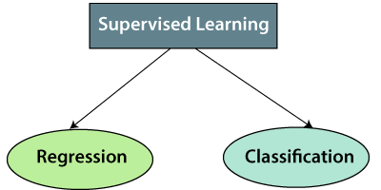

**1. Regression**

Regression algorithms are used if there is a relationship between the input variable and the output variable. It is used for the prediction of continuous variables, such as Weather forecasting, Market Trends, etc. Below are some popular Regression algorithms which come under supervised learning:

* Linear Regression
* Regression Trees
* Non-Linear Regression
* Bayesian Linear Regression
* Polynomial Regression

**2. Classification**

Classification algorithms are used when the output variable is categorical, which means there are two classes such as Yes-No, Male-Female, True-false, etc.

Spam Filtering,

* Random Forest
* Decision Trees
* Logistic Regression
* Support vector Machines

## Advantages of Supervised learning:

* With the help of supervised learning, the model can predict the output on the basis of prior experiences.
* In supervised learning, we can have an exact idea about the classes of objects.
* Supervised learning model helps us to solve various real-world problems such as **fraud detection, spam filtering**, etc.

## Disadvantages of supervised learning:

* Supervised learning models are not suitable for handling the complex tasks.
* Supervised learning cannot predict the correct output if the test data is different from the training dataset.
* Training required lots of computation times.
* In supervised learning, we need enough knowledge about the classes of object.

1. **Explain unsupervised learning.**

Unsupervised Machine Learning

In the previous topic, we learned supervised machine learning in which models are trained using labeled data under the supervision of training data. But there may be many cases in which we do not have labeled data and need to find the hidden patterns from the given dataset. So, to solve such types of cases in machine learning, we need unsupervised learning techniques.

What is Unsupervised Learning?

As the name suggests, unsupervised learning is a machine learning technique in which models are not supervised using training dataset. Instead, models itself find the hidden patterns and insights from the given data. It can be compared to learning which takes place in the human brain while learning new things. It can be defined as:

Unsupervised learning is a type of machine learning in which models are trained using unlabeled dataset and are allowed to act on that data without any supervision.

Unsupervised learning cannot be directly applied to a regression or classification problem because unlike supervised learning, we have the input data but no corresponding output data. The goal of unsupervised learning is to **find the underlying structure of dataset, group that data according to similarities, and represent that dataset in a compressed format**.

**Example:** Suppose the unsupervised learning algorithm is given an input dataset containing images of different types of cats and dogs. The algorithm is never trained upon the given dataset, which means it does not have any idea about the features of the dataset. The task of the unsupervised learning algorithm is to identify the image features on their own. Unsupervised learning algorithm will perform this task by clustering the image dataset into the groups according to similarities between images.

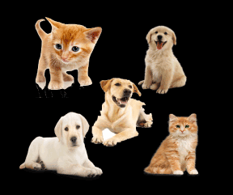

Why use Unsupervised Learning?

Below are some main reasons which describe the importance of Unsupervised Learning:

* Unsupervised learning is helpful for finding useful insights from the data.
* Unsupervised learning is much similar as a human learns to think by their own experiences, which makes it closer to the real AI.
* Unsupervised learning works on unlabeled and uncategorized data which make unsupervised learning more important.
* In real-world, we do not always have input data with the corresponding output so to solve such cases, we need unsupervised learning.

Working of Unsupervised Learning

Working of unsupervised learning can be understood by the below diagram:

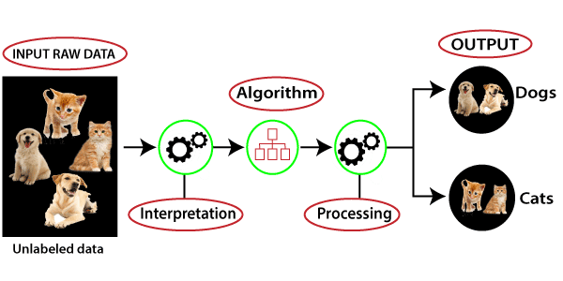

Here, we have taken an unlabeled input data, which means it is not categorized and corresponding outputs are also not given. Now, this unlabeled input data is fed to the machine learning model in order to train it. Firstly, it will interpret the raw data to find the hidden patterns from the data and then will apply suitable algorithms such as k-means clustering, Decision tree, etc.

Once it applies the suitable algorithm, the algorithm divides the data objects into groups according to the similarities and difference between the objects.

**Types of Unsupervised Learning Algorithm:**

The unsupervised learning algorithm can be further categorized into two types of problems:

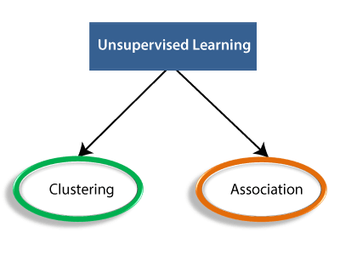

* **Clustering**: Clustering is a method of grouping the objects into clusters such that objects with most similarities remains into a group and has less or no similarities with the objects of another group. Cluster analysis finds the commonalities between the data objects and categorizes them as per the presence and absence of those commonalities.
* **Association**: An association rule is an unsupervised learning method which is used for finding the relationships between variables in the large database. It determines the set of items that occurs together in the dataset. Association rule makes marketing strategy more effective. Such as people who buy X item (suppose a bread) are also tend to purchase Y (Butter/Jam) item. A typical example of Association rule is Market Basket Analysis.

1. **Explain reinforcement learning.**

 Reinforcement Learning

**Reinforcement learning works on a feedback-based process, in which an AI agent (A software component) automatically explore its surrounding by hitting & trail, taking action, learning from experiences, and improving its performance.** Agent gets rewarded for each good action and get punished for each bad action; hence the goal of reinforcement learning agent is to maximize the rewards.

In reinforcement learning, there is no labelled data like supervised learning, and agents learn from their experiences only.

The [reinforcement learning](https://www.javatpoint.com/reinforcement-learning) process is similar to a human being; for example, a child learns various things by experiences in his day-to-day life. An example of reinforcement learning is to play a game, where the Game is the environment, moves of an agent at each step define states, and the goal of the agent is to get a high score. Agent receives feedback in terms of punishment and rewards.

Due to its way of working, reinforcement learning is employed in different fields such as **Game theory, Operation Research, Information theory, multi-agent systems.**

A reinforcement learning problem can be formalized using **Markov Decision Process(MDP).** In MDP, the agent constantly interacts with the environment and performs actions; at each action, the environment responds and generates a new state.

### Categories of Reinforcement Learning

Reinforcement learning is categorized mainly into two types of methods/algorithms:

* **Positive Reinforcement Learning:** Positive reinforcement learning specifies increasing the tendency that the required behaviour would occur again by adding something. It enhances the strength of the behaviour of the agent and positively impacts it.
* **Negative Reinforcement Learning:** Negative reinforcement learning works exactly opposite to the positive RL. It increases the tendency that the specific behaviour would occur again by avoiding the negative condition.

### Real-world Use cases of Reinforcement Learning

* **Video Games:**  
  RL algorithms are much popular in gaming applications. It is used to gain super-human performance. Some popular games that use RL algorithms are **AlphaGO** and **AlphaGO Zero**.
* **Resource Management:**  
  The "Resource Management with Deep Reinforcement Learning" paper showed that how to use RL in computer to automatically learn and schedule resources to wait for different jobs in order to minimize average job slowdown.
* **Robotics:**  
  RL is widely being used in Robotics applications. Robots are used in the industrial and manufacturing area, and these robots are made more powerful with reinforcement learning. There are different industries that have their vision of building intelligent robots using AI and Machine learning technology.
* **Text Mining**  
  Text-mining, one of the great applications of NLP, is now being implemented with the help of Reinforcement Learning by Salesforce company.

### Advantages and Disadvantages of Reinforcement Learning

**Advantages**

* It helps in solving complex real-world problems which are difficult to be solved by general techniques.
* The learning model of RL is similar to the learning of human beings; hence most accurate results can be found.
* Helps in achieving long term results.

**Disadvantage**

ADVERTISEMENT

* RL algorithms are not preferred for simple problems.
* RL algorithms require huge data and computations.
* Too much reinforcement learning can lead to an overload of states which can weaken the results.

1. **Explain machine learning problem categories.(same as types of machine learning)**
2. **Explain supervised learning problem categories.**

Supervised Machine Learning

As its name suggests, [Supervised machine learning](https://www.javatpoint.com/supervised-machine-learning) is based on supervision. It means in the supervised learning technique, we train the machines using the "labelled" dataset, and based on the training, the machine predicts the output. Here, the labelled data specifies that some of the inputs are already mapped to the output. More preciously, we can say; first, we train the machine with the input and corresponding output, and then we ask the machine to predict the output using the test dataset.

Let's understand supervised learning with an example. Suppose we have an input dataset of cats and dog images. So, first, we will provide the training to the machine to understand the images, such as the **shape & size of the tail of cat and dog, Shape of eyes, colour, height (dogs are taller, cats are smaller), etc.** After completion of training, we input the picture of a cat and ask the machine to identify the object and predict the output. Now, the machine is well trained, so it will check all the features of the object, such as height, shape, colour, eyes, ears, tail, etc., and find that it's a cat. So, it will put it in the Cat category. This is the process of how the machine identifies the objects in Supervised Learning.

**The main goal of the supervised learning technique is to map the input variable(x) with the output variable(y).** Some real-world applications of supervised learning are **Risk Assessment, Fraud Detection, Spam filtering,** etc.

### Categories of Supervised Machine Learning

Supervised machine learning can be classified into two types of problems, which are given below:

* **Classification**
* **Regression**

### a) Classification

Classification algorithms are used to solve the classification problems in which the output variable is categorical, such as "**Yes" or No, Male or Female, Red or Blue, etc**. The classification algorithms predict the categories present in the dataset. Some real-world examples of classification algorithms are **Spam Detection, Email filtering, etc.**

Some popular classification algorithms are given below:

* **Random Forest Algorithm**
* **Decision Tree Algorithm**
* **Logistic Regression Algorithm**
* **Support Vector Machine Algorithm**

### b) Regression

Regression algorithms are used to solve regression problems in which there is a linear relationship between input and output variables. These are used to predict continuous output variables, such as market trends, weather prediction, etc.

Some popular Regression algorithms are given below:

* **Simple Linear Regression Algorithm**
* **Multivariate Regression Algorithm**
* **Decision Tree Algorithm**
* **Lasso Regression**

### Advantages and Disadvantages of Supervised Learning

**Advantages:**

* Since supervised learning work with the labelled dataset so we can have an exact idea about the classes of objects.
* These algorithms are helpful in predicting the output on the basis of prior experience.

**Disadvantages:**

* These algorithms are not able to solve complex tasks.
* It may predict the wrong output if the test data is different from the training data.
* It requires lots of computational time to train the algorithm.

### Applications of Supervised Learning

Some common applications of Supervised Learning are given below:

* **Image Segmentation:**  
  Supervised Learning algorithms are used in image segmentation. In this process, image classification is performed on different image data with pre-defined labels.
* **Medical Diagnosis:**  
  Supervised algorithms are also used in the medical field for diagnosis purposes. It is done by using medical images and past labelled data with labels for disease conditions. With such a process, the machine can identify a disease for the new patients.
* **Fraud Detection -** Supervised Learning classification algorithms are used for identifying fraud transactions, fraud customers, etc. It is done by using historic data to identify the patterns that can lead to possible fraud.
* **Spam detection -** In spam detection & filtering, classification algorithms are used. These algorithms classify an email as spam or not spam. The spam emails are sent to the spam folder.
* **Speech Recognition -** Supervised learning algorithms are also used in speech recognition. The algorithm is trained with voice data, and various identifications can be done using the same, such as voice-activated passwords, voice commands, etc.

1. **Explain unsupervised learning problem categories**

Categories of Unsupervised Machine Learning

Unsupervised Learning can be further classified into two types, which are given below:

* **Clustering**
* **Association**

### 1) Clustering

The clustering technique is used when we want to find the inherent groups from the data. It is a way to group the objects into a cluster such that the objects with the most similarities remain in one group and have fewer or no similarities with the objects of other groups. An example of the clustering algorithm is grouping the customers by their purchasing behaviour.

Some of the popular clustering algorithms are given below:

* **K-Means Clustering algorithm**
* **Mean-shift algorithm**
* **DBSCAN Algorithm**
* **Principal Component Analysis**
* **Independent Component Analysis**

### 2) Association

Association rule learning is an unsupervised learning technique, which finds interesting relations among variables within a large dataset. The main aim of this learning algorithm is to find the dependency of one data item on another data item and map those variables accordingly so that it can generate maximum profit. This algorithm is mainly applied in **Market Basket analysis, Web usage mining, continuous production**, etc.

Some popular algorithms of Association rule learning are **Apriori Algorithm, Eclat, FP-growth algorithm.**

### Advantages and Disadvantages of Unsupervised Learning Algorithm

**Advantages:**

* These algorithms can be used for complicated tasks compared to the supervised ones because these algorithms work on the unlabeled dataset.
* Unsupervised algorithms are preferable for various tasks as getting the unlabeled dataset is easier as compared to the labelled dataset.

**Disadvantages:**

* The output of an unsupervised algorithm can be less accurate as the dataset is not labelled, and algorithms are not trained with the exact output in prior.
* Working with Unsupervised learning is more difficult as it works with the unlabelled dataset that does not map with the output.

### Applications of Unsupervised Learning

* **Network Analysis:** Unsupervised learning is used for identifying plagiarism and copyright in document network analysis of text data for scholarly articles.
* **Recommendation Systems:** Recommendation systems widely use unsupervised learning techniques for building recommendation applications for different web applications and e-commerce websites.
* **Anomaly Detection:** Anomaly detection is a popular application of unsupervised learning, which can identify unusual data points within the dataset. It is used to discover fraudulent transactions.
* **Singular Value Decomposition:** Singular Value Decomposition or SVD is used to extract particular information from the database. For example, extracting information of each user located at a particular location.

1. **Draw and explain machine learning architecture**

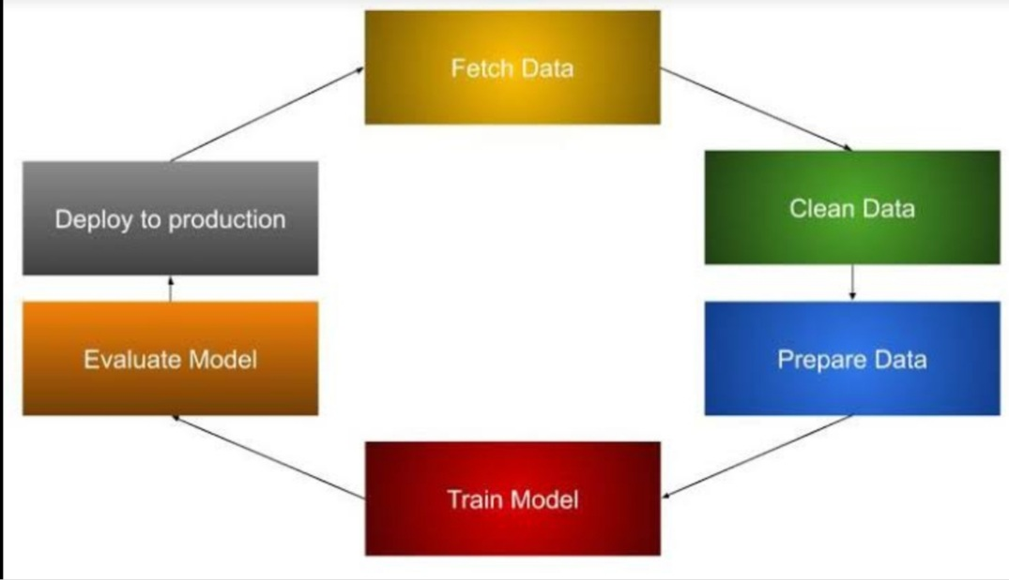

1. 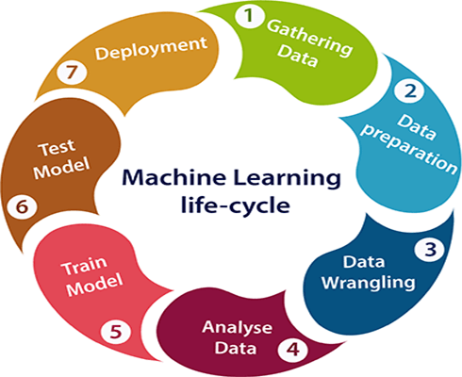**Draw and explain machine learning lifecycle.**

1.Gathering Data:

Data Gathering is the first step of the machine learning life cycle. The goal of this step is to identify and obtain all data-related problems.

In this step, we need to identify the different data sources, as data can be collected from various sources such as **files**, **database**, **internet**, or **mobile devices**. It is one of the most important steps of the life cycle. The quantity and quality of the collected data will determine

the efficiency of the output. The more will be the data, the more accurate will be the prediction.

This step includes the below tasks:

* **Identify various data sources**
* **Collect data**
* **Integrate the data obtained from different sources**

By performing the above task, we get a coherent set of data, also called as a **dataset**. It will be used in further steps.

## 2.Data preparation

After collecting the data, we need to prepare it for further steps. Data preparation is a step where we put our data into a suitable place and prepare it to use in our machine learning training.

In this step, first, we put all data together, and then randomize the ordering of data. This step can be further divided into two processes:

* + **Data exploration:**

It is used to understand the nature of data that we have to work with. We need to understand the characteristics, format, and quality of data. A better understanding of data leads to an effective outcome. In this, we find Correlations, general trends, and outliers.

* + **Datapre-processing:**

Now the next step is preprocessing of data for its analysis.

3.Data Wrangling

Data wrangling is the process of cleaning and converting raw data into a useable format. It is the process of cleaning the data, selecting the variable to use, and transforming the data in a proper format to make it more suitable for analysis in the next step. It is one of the most important steps of the complete process. Cleaning of data is required to address the quality issues.

It is not necessary that data we have collected is always of our use as some of the data may not be useful. In real-world applications, collected data may have various issues, including:

* + **Missing Values**
  + **Duplicate data**
  + **Invalid data**
  + **Noise**

**4.**Data Analysis

Now the cleaned and prepared data is passed on to the analysis step. This step involves:

* + **Selection of analytical techniques**
  + **Building models**
  + **Review the result**

The aim of this step is to build a machine learning model to analyze the data using various analytical techniques and review the outcome. It starts with the determination of the type of the problems, where we select the machine learning techniques such as **Classification**, **Regression**, **Cluster analysis**, **Association**, etc. then build the model using prepared data, and evaluate the model.

## 5.Train Model

Now the next step is to train the model, in this step we train our model to improve its performance for better outcome of the problem.

We use datasets to train the model using various machine learning algorithms. Training a model is required so that it can understand the various patterns, rules, and, features.

6.Test Model

Once our machine learning model has been trained on a given dataset, then we test the model. In this step, we check for the accuracy of our model by providing a test dataset to it.

Testing the model determines the percentage accuracy of the model as per the requirement of project or problem.

## 7.Deployment

The last step of machine learning life cycle is deployment, where we deploy the model in the real-world system.

If the above-prepared model is producing an accurate result as per our requirement with acceptable speed, then we deploy the model in the real system. But before deploying the project, we will check whether it is improving its performance using available data or not. The deployment phase is similar to making the final report for a project.

|  |
| --- |
| 10.Explain performance measures for machine learning |



